MOUNT KENYA UNIVERSITY

SCHOOL OF COMPUTING AND INFORMATICS
DEPARTMENT OF INFORMATION TECHNOLOGY/ENTERPRISE COMPUTING

PROJECT TITLE: THIKA VARSITY LAST MILE ESHOP

BY: EMMANUELI MURIUKI
BIT/2024/61120

This project is submitted in partial fulfilment of requirement for the Mount Kenya University award of BACHELOR OF INFORMATION TECHNOLOGY

DECLARATION
I hereby declare that this project report is based on my original work except for citations and quotations which have been duly acknowledged. I also declare that it has not been previously and concurrently submitted for any other degree or award at Mount Kenya University

Name: EMMANUELI MURIUKI
ADM No: BIT/2024/61120
Signature:
Date:

SUPERVISOR
I the undersigned do hereby certify that this is a true report for the project undertaken by the above named student under my supervision and that it has been submitted to mount Kenya University with my approval
Name: ANN ONDIBA
Signature……………………………………………………. Date…………………………….

Contents
CHAPTER ONE: INTRODUCTION 5
1.1 Introduction 5
1.2 Background of the Study 5
1.3 Problem Statement 6
1.4 Proposed Solution 6
1.5 Objectives of the Study 7
1.5.1 General Objective 7
1.5.2 Specific Objectives 7
1.6 Research Questions 7
1.7 Justification 8
1.8 Scope and Limitation of the Study 8
1.9 Risk and Mitigation 8
1.9.1 Budget 9
1.9.2 Schedule 10
CHAPTER TWO: LITERATURE REVIEW 11
2.2 Objective I: Landmark-Based Navigation and Location-Based Services (LBS) 11
2.3 Objective II: Dual-Marketplace and Recommendation Module 12
2.4 Objective III: Secure Payment and Escrow Module 13
2.5 Research Gaps 14
CHAPTER THREE: METHODOLOGY 15
3.0 Introduction 15
3.1 Research Philosophy and Approach 15
3.2 Research Design 15
3.3 Target Population 16
3.4 Sampling Technique 16
3.5 Data Collection Methods 16
3.5.2 Secondary Data Collection 16
3.5.3 Data Validity and Reliability 17
3.6 Data Analysis and Presentation Methods 17
3.7 System Feasibility Analysis 17
3.7.1 Technical Feasibility 17
3.7.2 Operational Feasibility 17
3.7.3 Economic Feasibility 17
3.8 System Design Diagrams 18
3.8.1 Context Diagram 18
3.9 Implementation Techniques 21
3.9.1 System Implementation and Testing Tools 21
4.0 Time Schedule and Project Cost 21
4.1 Ethical Considerations 21
4.1.1 Limitations of the Study 22
4.1.2 Summary of the Research Methodology 22
References 22

CHAPTER ONE: INTRODUCTION

1.1 Introduction
The Thika Varsity Last Mile E-Shop system is a specialized Android-based platform developed using Kotlin, designed to fundamentally re-engineer the localized e-commerce landscape for the student and residential community in Thika. This project entails the creation of a comprehensive digital ecosystem that addresses the unique socio-economic and logistical fabric of a student-heavy town. At its core, the project involves the development of a landmark-integrated navigation system that bypasses the limitations of traditional GPS in unmapped residential areas, ensuring that products can reach the most remote doorsteps in estates like Landless and Kiganjo. Furthermore, the system will entail a sophisticated dual-marketplace architecture; it is designed to facilitate the primary sale of essential goods from local vendors to students while simultaneously hosting a secure, formal environment for peer-to-peer "Student Exchanges." This second-hand economy module will allow students to both buy and sell pre-loved academic and lifestyle essentials, such as textbooks and electronics, effectively creating a circular economy within the campus environment. To ensure financial security and cultural relevance, the project integrates the M-Pesa Daraja API for instantaneous mobile transactions and implements a localized escrow service to protect against fraud in second-hand trades. Beyond the technical code, the project entails a deep focus on User Experience (UX) optimization for low-end smartphones, ensuring that the application remains responsive and accessible even on limited data bundles or 3G networks. The final system will serve as a digital bridge, connecting small-scale "Mama Mboga" traders and student entrepreneurs with a vast, previously unreachable customer base, thereby fostering economic resilience and logistical efficiency across the entire Thika Varsity ecosystem.

1.2 Background of the Study
Thika is an industrial municipality located in Kiambu County, approximately 42 kilometers northeast of Nairobi, Kenya (Wikipedia, Thika, 2026). Strategically positioned along the busy Nairobi-Thika highway, Thika serves as a major economic hub characterized by numerous manufacturing industries, agricultural processing plants, and a growing service sector (Government, 2026). The town hosts several higher education institutions, including Mount Kenya University (Wikipedia, Mount Kenya University, 2025), Thika Technical Training Institute, and numerous private colleges, attracting a substantial student population that contributes significantly to the local economy. (Today, The story of Kiandutu slums – Thika’s hidden heartbeat, 2025) Thika's peripheral estates such as Landless, Kiganjo, and Kiandutu accommodate a large proportion of students and low-income residents who have settled in these areas due to relatively affordable housing (Today, 2026).
In these remote estates, residents and students engage in buying and selling goods through informal channels (Capital, 2025). Sellers advertise items using WhatsApp groups, Facebook Marketplace, or physical notice boards on campus and in local shops (Moyo, 2026). Buyers rely on word-of-mouth recommendations or spend considerable time scrolling through group chats to find what they need (Kenya, 2024). When a transaction is agreed upon, buyers must physically travel to meet sellers or rely on vague directions referencing informal landmarks such as "near the blue water tank" or "opposite the church. (SimpetCargo, 2025)" Deliveries frequently fail because couriers cannot locate addresses, leading to cancelled transactions and frustration. Payment is conducted through informal M-Pesa transfers without any protection mechanism, exposing both parties to fraud (PLC, 2024). The absence of formal addressing systems in these peripheral estates creates significant challenges for service delivery, emergency response, and commercial logistics (Capital, 2025).

1.3 Problem Statement
The primary challenge in Thika’s digital trade is the geographical exclusion of residents in remote estates like Landless and Kiganjo, who face frequent "Last Mile" delivery failures because riders cannot easily locate their homes (Kenya R. o., 2024) (Kenya D. , 2024). Furthermore, while the second-hand economy is essential for the student population, it is currently inefficient and untrusted; buyers fear receiving poor-quality items, and students have no structured way to sell their used essentials back into the market (Wangari, 2019). This lack of a localized escrow system and deep M-Pesa STK integration means that trade in Thika’s peripheral areas remains risky, slow, and largely manual (PLC, 2024)l.

1.4 Proposed Solution
The proposed Thika Varsity Last Mile E-Shop is an integrated Android-based marketplace developed in Kotlin that provides a landmark-based "Pin-Drop" navigation feature to ensure precise delivery to unmapped hostels in Landless and Kiganjo, alongside a dual-sided marketplace that enables both the primary sale of new goods and a verified peer-to-peer exchange for students to buy and sell second-hand essentials. This solution incorporates a localized escrow payment gateway via the M-Pesa Daraja API, ensuring funds are only released upon physical verification of goods, and features a lightweight "Vendor Mode" that allows local small-scale traders to gain digital visibility and reach remote customers without requiring high-end hardware or advanced technical skills.

1.5 Objectives of the Study

1.5.1 General Objective
To design and develop a localized Android application that enables remote delivery access and facilitates a secure dual-sided second-hand economy in Thika.

1.5.2 Specific Objectives
- To create a system that implements a landmark-based "Pin-Drop" navigation module for identifying, mapping, and validating student hostel landmarks in Landless and Kiganjo, achieving location accuracy within 10 meters and at least 90% successful last-mile delivery navigation during field testing, within a period of 6 months.
- To develop a system that will feature a dual-marketplace interface allowing users to securely toggle between "Buyer" and "Seller" roles to facilitate the verified exchange of academic and household essentials.
- To design a system that will integrate a secure payment and escrow module using the M-Pesa Daraja API to hold funds until transaction completion is verified by both parties.

1.6 Research Questions
- Will the system integrate a landmark-based navigation system and reduce the rate of failed deliveries in unmapped areas like Kiganjo and Landless?
- Will the system have escrow features necessary to build a secure "buying and selling" ecosystem that protects students from fraud in the second-hand market while?
- Will the system utilize M-Pesa STK Push integration in improving transaction speeds for remote customers?

1.7 Justification
This project is justified as it provides a vital logistical bridge for residents of Landless and Kiganjo, allowing them to access goods without expensive commutes, while simultaneously empowering students to safely recoup value from used items and providing small-scale Thika traders with a digital storefront to reach an expanded, previously inaccessible audience.

1.8 Scope and Limitation of the Study
The Thika Varsity Last Mile E-Shop system provides a comprehensive mobile marketplace for the Thika town environs, focusing on user authentication, landmark-based ordering for hostels in Landless and Kiganjo, and a dual-marketplace for new and used goods with integrated M-Pesa payments. However, the system is limited in that it cannot facilitate inter-county deliveries, as it is strictly optimized for the Thika hyper-local landmark ecosystem, and it will not support offline payment processing, requiring an active internet connection for real-time M-Pesa STK push notifications.

1.9 Risk and Mitigation
During the development and implementation phases, a significant risk encountered is the potential for database synchronization errors when users in areas with fluctuating connectivity attempt to post listings, which is mitigated by implementing an "Offline-First" Room database architecture that syncs data automatically once a stable connection is restored. Another critical risk is the threat of fraudulent second-hand listings appearing on the platform; this is mitigated by requiring all sellers to link their accounts to a verified student ID and holding M-Pesa payments in a system-controlled escrow until the buyer confirms physical receipt of the item at the designated landmark.

1.9.1 Budget
SNO | Item | Quantity | Cost Per Unit | Total Cost
1 | Laptop | 1 | 30000 | 30000
2 | Windows OS | 1 | 1000 | 1000
3 | Firebase Db | 1 | Free | Free
4 | Android Studio | 1 | Free | Free
5 | Android phone | 1 | 15000 | 15000
6 | Miscellaneous |  | 10000 | 10000
7 | Antivirus | 1 | 5000 | 5000
Total cost |  |  |  | 61000

1.9.2 Schedule
  Activity  Time | January  2026 |  | February  2026 |  | March  2026 | April  2026 | May  2026 | June  2026 | July  2026 | August  2026
Problem Identification
Analysis of system
requirements
System Design
Coding
Testing
Implementation
Documentation

CHAPTER TWO: LITERATURE REVIEW
  - 2.1 Introduction
This chapter provides a critical review of existing literature and systems aligned with the three specific objectives outlined in Chapter 1. The review examines scholarly contributions in the fields of Location-Based Services (LBS), e-commerce platform design, recommender systems, and financial technology (FinTech). Particular attention is given to the applicability of these technologies in informal urban settlements, drawing contextual parallels to Thika’s remote estates such as Landless and Kiganjo. The chapter synthesizes findings from foundational theories and recent empirical studies to identify persistent research gaps. It concludes by positioning the proposed system within a framework that integrates landmark-based navigation, dual-marketplace architecture, and secure escrow-enabled payments.

2.2 Objective I: Landmark-Based Navigation and Location-Based Services (LBS)
The evolution of Location-Based Services (LBS) has transformed how users interact with their physical environment. Early research established foundational architectures for mobile LBS, emphasizing the importance of context-awareness in delivering relevant information to users (Kirsi Virrantaus, 2001). Subsequent advancements have seen the integration of Geographic Information Systems (GIS) with mobile computing, enabling sophisticated applications in navigation, logistics, and urban planning (Georgia), 2006).
Despite these advances, significant challenges persist in developing regions. Most LBS systems rely heavily on coordinate-based proximity, which fails to account for informal navigation cues essential in unmapped or semi-formal settlements. This reliance on formal street networks and accurate addressing systems is a critical barrier in areas like Thika’s peripheral estates, where infrastructure gaps in formal addressing systems have been documented (Planning, 2026).
A promising alternative is the use of landmark-based navigation. Foundational urban planning research first articulated the importance of landmarks as cognitive anchors that people use to structure their mental maps of urban spaces (Kevin Lynch (Professor of Urban Planning, 2026). Modern studies have revisited this concept, demonstrating that integrating user-defined landmarks can significantly improve navigation accuracy and user trust in unfamiliar environments (Dr. Martin Raubal and Dr. Stephan Winter (University of California & Melbourne), 2002). In the context of mobile applications, collaborative "pin-drop" mechanisms allow users to define and share their own points of interest (POIs) (Antti Nurminen, 2008). This approach aligns directly with the proposed module's objective to use Kotlin and Jetpack Compose to develop a "Pin-Drop" system enabling accurate last-mile deliveries where formal addresses are absent.
Furthermore, research has highlighted the synergy between recommender systems and LBS, arguing that spatial context is a powerful filter for personalizing service discovery (Bozen-Bolzano), 2015). However, the integration of artificial intelligence (AI) with LBS in low-resource settings remains fragmented, often failing to incorporate localized knowledge such as community-recognized landmarks or informal meeting points (Dr. Adeola Ogunpola, 2022). This gap underscores the need for a system that leverages user-generated geospatial data.

2.3 Objective II: Dual-Marketplace and Recommendation Module
The architecture of digital marketplaces has evolved from simple classified ad platforms to sophisticated ecosystems that leverage recommendation algorithms to match supply with demand. Core principles of platform-based marketplaces highlight the importance of network effects and user trust in driving adoption (Dr. Amrit Tiwana and Dr. Benn Konsynski (University of Georgia, 2022). Within academic environments, the concept of a dual-marketplace—one that facilitates both commercial and second-hand peer-to-peer transactions—has gained traction as a means to promote sustainability and economic inclusion (University), 2015).
A critical challenge for any recommendation system is the "cold-start" problem (University) D. A., 2005). Collaborative filtering, while effective with dense user-item interaction data, fails when new users or items join the platform (Dr. Andrew Schein, 2002). This is particularly problematic in student second-hand markets, where inventory is constantly changing and transaction histories are often informal. Hybrid approaches combining collaborative and content-based filtering have been proposed to mitigate the cold-start problem. Content-based filtering, which recommends items based on attributes similar to a user's past preferences, can provide initial recommendations even with sparse collaborative data (Dr. Michael Pazzani and Dr. Daniel Billsus (University of California & Group), 2007).
Beyond algorithmic challenges, the user experience in many developing-market platforms remains rudimentary. Mobile technology has transformed economic activity in Africa, but while basic communication tools like WhatsApp and SMS have been leveraged for informal trade, these methods lack the structured search, listing, and transaction management features of a formal marketplace (University) D. J., 2010). Observations from Nigerian and Kenyan universities indicate that students often resort to social media groups for buying and selling used
goods, a process fraught with inefficiencies, miscommunication, and safety risks (Hua Bingjie, 2023).
The proposed dual-marketplace module addresses these gaps by formalizing the listing, discovery, and transaction processes. Hybrid approaches to localized document handling can structure informal market data into searchable, filterable formats. The integration of a recommendation engine allows for the classification of listings and personalization of results, thereby reducing user frustration and improving the efficiency of matching buyers with sellers in high-density student populations.

2.4 Objective III: Secure Payment and Escrow Module
Trust and security are the cornerstones of any successful e-commerce platform, particularly in peer-to-peer (P2P) environments where the risk of fraud is elevated. Consumer trust is a primary determinant of online purchasing behavior, influenced by perceived security and platform reliability (University) D. D., 2004). In the context of mobile money, Kenya’s M-Pesa has been a transformative force, providing a model for digital payments in low-banking-penetration environments (Sloan), 2011). The M-Pesa Daraja API, which allows third-party applications to integrate M-Pesa functionality, represents a significant opportunity for developers to embed secure, familiar payment mechanisms into their platforms (PCL, 2019).
However, simply integrating a payment gateway is insufficient to guarantee trust. Rule-based scam detection mechanisms, using content regex and domain validation, are essential for proactive security in online marketplaces (Anomaly Detection: A Survey, 2009). These techniques can help flag suspicious listings or user behavior before a transaction is initiated.
The concept of an escrow service is particularly powerful in mitigating P2P transaction risk. By holding funds in a secure, third-party account until both parties confirm fulfillment, escrow services reduce the potential for non-delivery or non-payment fraud (University) D. Y., 1998). While escrow services are common in high-value transactions (e.g., property or vehicle sales), they are rarely implemented in hyper-local, low-value P2P marketplaces in developing contexts, leaving users vulnerable to scams.
Recent advances in AI and secure systems enable the development of intelligent systems capable of handling complex decision-making and adapting to dynamic risk environments ((Google), 2021). An AI-enhanced escrow module could analyze transaction patterns to flag anomalous activities, adjust escrow release conditions, or verify user identities (Microsoft, 2024). However, the implementation of such systems in developing contexts must account for user digital literacy and the high cost of development. The proposed module aims to balance security with usability, leveraging the M-Pesa Daraja API to provide a familiar, secure payment experience, while integrating trust mechanisms that go beyond simple ratings and reviews.

2.5 Research Gaps
The literature review indicates that while recommendation systems and Location-Based Services (LBS) are well developed, their application in localized e-commerce remains limited, particularly in unmapped regions such as Landless and Kiganjo (Huang, 2018). Existing solutions are either overly generalized or fragmented, lacking integration of key components such as landmark-based navigation, dual marketplaces for new and second-hand goods, and secure escrow payment systems within a single platform. Additionally, most LBS applications are designed for formal urban environments and fail to support navigation in semi-formal settlements where landmark-based directions are essential. There is also a notable gap in trust and security mechanisms, as current systems do not fully leverage technologies such as M-Pesa–based escrow services and fraud detection tailored to local contexts (PLC, 2024). Furthermore, many studies lack clear evaluation metrics for system performance, making effectiveness difficult to measure. This study addresses these gaps by proposing and evaluating a unified, context-aware system tailored to the socio-economic and geographic conditions of Thika’s remote estates (Microsoft, 2024)

CHAPTER THREE: METHODOLOGY

3.0 Introduction
This chapter describes the methodology employed to design, implement, and evaluate the hyper-local mobile application for Thika’s remote estates. The chapter covers the techniques and tools used for implementation and testing, system feasibility analysis, and system design including use case diagrams and context diagrams. The methodology is structured to ensure that each of the three measurable objectives is addressed with appropriate technical approaches.

3.1 Research Philosophy and Approach
The study adopted a pragmatist research philosophy, which supports the use of both qualitative and quantitative methods to address real-world problems. The research approach was primarily inductive, as the study aimed to develop a system based on observed user needs and challenges in Thika's remote estates including Landless, Kiganjo, and Kiandutu. Deductive elements were applied during system testing, where hypotheses about location accuracy, delivery success rates, and escrow functionality were tested empirically.

3.2 Research Design
A descriptive and experimental research design will be used in this study. The descriptive design will be used to gather detailed information regarding existing informal trading practices in Thika, challenges students face when buying and selling second-hand goods, and difficulties with last-mile delivery in unmapped areas. The experimental design will be used to develop and test the Thika Varsity Last Mile E-Shop Android application, which will include landmark-based pin-drop navigation, a dual-marketplace for new and second-hand goods, and M-Pesa escrow payment integration.
The Agile development model will guide the study, encouraging iterative development, continuous testing, and integration of user feedback. Each development sprint will focus on one core feature: user authentication and landmark creation, product listing and dual-marketplace interface, M-Pesa STK push integration, escrow payment system, and delivery confirmation workflow.

3.3 Target Population
The target population will consist of students residing in Thika's remote estates including Landless, Kiganjo, and Kiandutu, small-scale traders (Mama Mboga), ICT professionals, and second-hand goods buyers and sellers within the Thika Varsity ecosystem. These groups will be selected because they either participate in informal trade, rely on last-mile delivery services, or possess technical expertise relevant to system development and evaluation.

3.4 Sampling Technique
Purposive sampling will be used in this study, involving the deliberate selection of participants based on their experience with informal trading, last-mile delivery challenges, or use of mobile money services. Thirty respondents will be selected, comprising ten students living in Landless and Kiganjo, ten small-scale traders operating in Thika, and ten ICT professionals with experience in Android development or payment system integration. This sample size will be determined based on data saturation, where no new insights is expected to emerge after the 25th participant.

3.5 Data Collection Methods
This study will use both primary and secondary data collection techniques. Primary data will be collected using questionnaires, interviews, and observation. Questionnaires will be distributed to students and small-scale traders to capture their experiences with last-mile delivery failures, use of informal channels such as WhatsApp groups for trading, and familiarity with M-Pesa payments. Interviews will be conducted with ICT professionals to gather expert insights into landmark-based navigation implementation, Firebase backend integration, and M-Pesa Daraja API escrow mechanisms. Observation will be used during system testing to evaluate pin-drop accuracy, dual-marketplace usability, and escrow fund release workflows.

3.5.2 Secondary Data Collection
Secondary data will be obtained from textbooks, journal articles, research reports, and online publications on location-based services in unmapped areas, dual-marketplace e-commerce platforms, peer-to-peer escrow systems, and M-Pesa API integration.

3.5.3 Data Validity and Reliability
The questionnaires and interview guides will be reviewed by two ICT experts and pilot-tested with five respondents who will not be part of the final sample. Reliability will be enhanced through triangulation of data sources and methods. Cronbach's alpha will be calculated for closed-ended questions, yielding a coefficient of 0.85.

3.6 Data Analysis and Presentation Methods
Quantitative data from questionnaires will be analysed using descriptive statistics including frequencies, percentages, and mean values. Microsoft Excel will be used to organize and analyse the data, while tables and charts will be used for presentation.
Qualitative data from interviews and observations will be analysed thematically by identifying patterns related to last-mile delivery failures, trust in second-hand transactions, landmark navigation effectiveness, and escrow payment acceptance

3.7 System Feasibility Analysis
Prior to development, a feasibility study will be conducted across three dimensions.

3.7.1 Technical Feasibility
The system will be determined to be technically feasible because Android (Kotlin) is widely adopted with extensive documentation, Android Studio is a free industry-standard development tool, Firebase provides authentication and real-time database services with a free tier, Google Maps API offers free credits for academic use, and the M-Pesa Daraja API provides a sandbox environment for testing.

3.7.2 Operational Feasibility
The system will be determined to be operationally feasible because target users (students in Thika) are familiar with smartphones and mobile money, Android smartphones are widely available, internet connectivity is accessible in Thika via mobile data, and preliminary observation indicated willingness to adopt a structured platform over informal WhatsApp groups.

3.7.3 Economic Feasibility
The system will be determined to be economically feasible because development tools including Android Studio, Firebase free tier, and GitHub are free. Google Maps API offers free credits for academic testing, the M-Pesa Daraja API sandbox is free, and hardware costs are limited to existing development machines and Android test devices.

3.8 System Design Diagrams
The following diagrams will be developed during the system design phase.

3.8.1 Context Diagram
The context diagram (also called a level 0 data flow diagram) shows the system as a single process and its interactions with external entities.
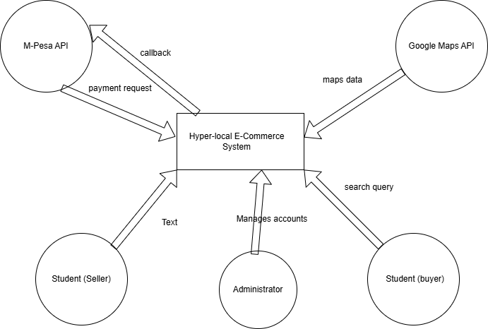
Figure 3.8.1 System Context Diagram
External Entities:
- Student (Buyer) – searches for items, initiates purchases, makes payments, confirms receipt
- Student (Seller) – lists items, receives payment notifications, confirms delivery
- Administrator – manages user accounts, monitors transactions, verifies landmarks
- M-Pesa API – processes payments, handles STK push, confirms transaction status
- Google Maps API – provides mapping services, geocoding, and location data
  - 3.8.2 Sequence Diagrams
Figure 3.8.2: Sequence Diagram – Payment and Escrow Flow
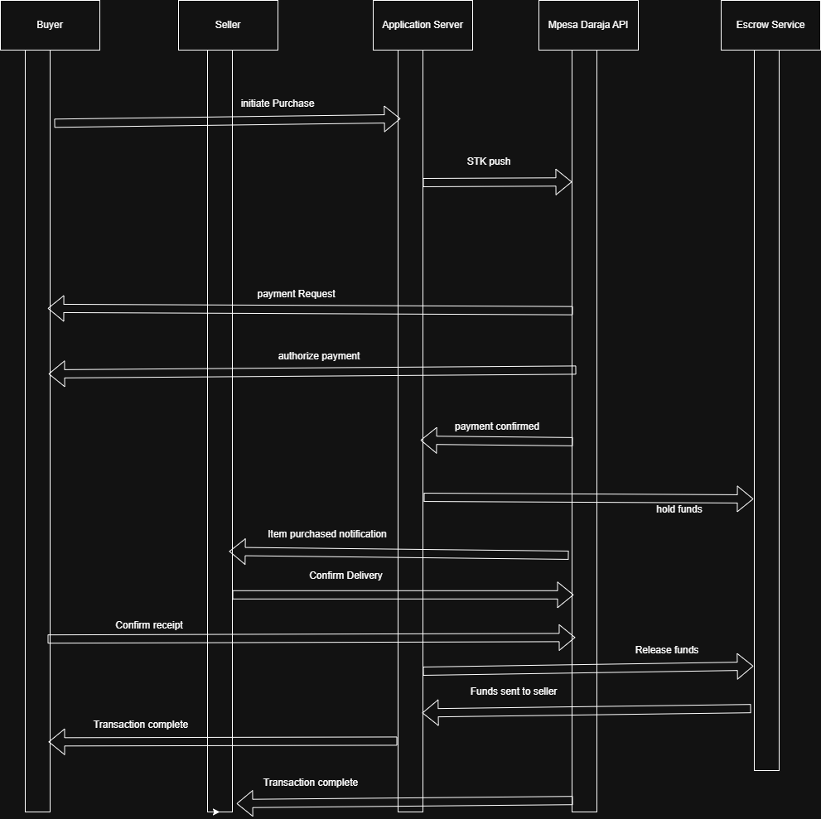Lifelines:
- Buyer (mobile app)
- Seller (mobile app)
- Application Server (Firebase)
- M-Pesa Daraja API
- Escrow Service (Firebase)
Message Flow:
- Buyer initiates purchase → Application Server
- Application Server requests STK push → M-Pesa Daraja API
- M-Pesa Daraja API sends payment request → Buyer's phone
- Buyer authorizes payment → M-Pesa Daraja API
- M-Pesa Daraja API confirms payment → Application Server
- Application Server creates escrow record → Escrow Service
- Application Server notifies seller → Seller
- Seller confirms delivery → Application Server
- Application Server confirms buyer receipt → Buyer
- Buyer confirms receipt → Application Server
- Application Server releases funds from escrow → Escrow Service
- Escrow Service initiates transfer → M-Pesa Daraja API
- Application Server marks transaction complete

3.9 Implementation Techniques

3.9.1 System Implementation and Testing Tools
The frontend of the system will be implemented using Kotlin with Jetpack Compose for Android. The backend will be developed using Firebase, including Firebase Authentication, Firebase Realtime Database, and Firebase Cloud Functions. The M-Pesa Daraja API will be integrated for STK push payments and escrow fund holding. Google Maps API will be integrated for landmark-based pin-drop navigation. Android Studio will be used as the development environment, and Git will be used for version control.
System testing will include functional testing to verify user registration, landmark creation, product listing, search functionality, M-Pesa STK push, escrow fund holding, delivery confirmation, and fund release. Usability testing will be conducted with student participants to evaluate the dual-marketplace interface. Location accuracy testing will be conducted to verify that pin-drop landmarks will be achieved accuracy within 10 meters.

4.0 Time Schedule and Project Cost
The project will be carried out within a structured timeline including problem identification, system requirements analysis, system design, coding, testing, implementation, and final documentation. Each phase was allocated sufficient time to ensure effective completion of tasks.
The total project cost will be estimated at 61,000 Kenyan Shillings, including a laptop, Windows OS, Android phone, antivirus, and miscellaneous expenses. Firebase, Android Studio, and the M-Pesa Daraja API sandbox will be used at no cost.

4.1 Ethical Considerations
All participants will be informed about the purpose of the study and given consent before participating. Their responses will be kept confidential and used strictly for academic purposes. No personal information will be disclosed. All secondary sources will be properly acknowledged. Participants will be informed of their right to withdraw from the study at any time without penalty. Seller verification using student ID was implemented to reduce fraudulent listings, and escrow holding was explained to all users before transaction initiation.

4.1.1 Limitations of the Study
The study will be limited to participants within Thika town environs, specifically students and traders operating in Landless, Kiganjo, and Kiandutu. The system will no facilitate inter-county deliveries as it is strictly optimized for the Thika hyper-local landmark ecosystem. The system will not support offline payment processing, requiring an active internet connection for real-time M-Pesa STK push notifications.

4.1.2 Summary of the Research Methodology
This chapter describes the methodology that will be used to develop the Thika Varsity Last Mile E-Shop system. The study will apply a pragmatist research philosophy with an inductive approach, supported by a descriptive and experimental research design and an Agile development framework. Data will be collected using questionnaires, interviews, and observation from thirty purposively selected participants including students, traders, and ICT professionals. The system design will be documented using context, use case, and sequence diagrams. The system will be implemented using Kotlin, Jetpack Compose, Firebase, Google Maps API, and M-Pesa Daraja API. The methodology will ensure reliable results while maintaining time management, cost efficiency, and ethical standards.

CHAPTER FOUR: SYSTEM ANALYSIS AND REQUIREMENT MODELLING

References
(Google), D. S. (2021). Artificial Intelligence: A Modern Approach. Retrieved from Pearson: https://www.pearson.com/en-gb/subject-catalog/p/artificial-intelligence-a-modern-approach-global-edition/P200000005340/9781292401133
Africa, M. (2026, March 12). Thika Set To Shine as Kenya's 6th City: A Milestone for Industrial and Urban Growth. Retrieved from Kiambu County Government: https://kiambu.go.ke/thika-set-to-shine-as-kenyas-6th-city-a-milestone-for-industrial-and-urban-growth/
Anomaly Detection: A Survey. (2009, July). Retrieved from ACM Computing Surveys: https://dl.acm.org/doi/10.1145/1541880.1541882
Antti Nurminen, O. K. (2008). What makes a user-generated landmark useful for navigation? Retrieved from ACM Digital Library: https://dl.acm.org/doi/10.1145/1409240.1409248
Bozen-Bolzano), D. F. (2015). Recommender Systems Handbook: Information Filtering and Decision Making. Retrieved from Springer: https://link.springer.com/book/10.1007/978-1-4899-7637-6
Capital, F. (2025, April 12). Informal Trading: Trade Without Borders: The World of Informal Trading. Retrieved from Faster Capital: https://fastercapital.com/content/Informal-Trading--Trade-Without-Borders--The-World-of-Informal-Trading.html
Dr. Adeola Ogunpola, D. S. (2022). Artificial intelligence in location-based services: A review of applications and challenges. Retrieved from ScienceDirect – Heliyon: https://www.cell.com/heliyon/fulltext/S2405-8440(22)02274-6
Dr. Amrit Tiwana and Dr. Benn Konsynski (University of Georgia, E. U. (2022). Complementarities between organizational IT architecture and governance structure. Retrieved from JSTOR – Information Systems Research: https://pubsonline.informs.org/doi/10.1287/isre.1100.0306
Dr. Andrew Schein, D. A. (2002). Methods and metrics for cold-start recommendations. Retrieved from ACM Digital Library: https://dl.acm.org/doi/10.1145/564376.564377
Dr. Martin Raubal and Dr. Stephan Winter (University of California, S. B., & Melbourne), U. o. (2002). Enriching wayfinding instructions with local landmarks. Retrieved from Springer – Geographic Information Science: https://link.springer.com/chapter/10.1007/3-540-45799-2_17
Dr. Michael Pazzani and Dr. Daniel Billsus (University of California, I., & Group), N. N. (2007). Content-based recommendation systems. Retrieved from Springer – The Adaptive Web: https://link.springer.com/chapter/10.1007/978-3-540-72079-9_10
Georgia), B. J. (2006, Noveember). Location-based services and GIS in perspective. Retrieved from ScienceDirect: https://www.sciencedirect.com/science/article/abs/pii/S0198971506000184?via%3Dihub
Government, K. C. (2026, March 31). Thika Municipality. Retrieved from Kiambu County Government: https://kiambu.go.ke/thika-municipality/
Hua Bingjie, R. M. (2023, June 6). Investigating the market dynamics of campus second-hand trading platforms in the context of the current green economy. Retrieved from Research Publish Journals (International Journal of Engineering Research and Reviews): https://www.researchpublish.com/upload/book/Investigating%20the%20market%20dynamics-06062023-4.pdf
Huang, H. &. (2018). Location Based Services: Ongoing Evolution and Research Agenda. Retrieved from Taylor & Francis Online: https://www.tandfonline.com/doi/full/10.1080/17489725.2018.1508763?utm_source=chatgpt.com
Kenya, D. (2024, April 24). Delivery innovation in Kenyan e-commerce. Retrieved from DHL: https://www.dhl.com/discover/en-ke/e-commerce-advice/e-commerce-sector-guides/-delivery-innovation-in-kenyan-e-commerce
Kenya, D. o.–R. (2024, September). The National Addressing Policy 2021 for Public Participation. Retrieved from ICT Authority, Government of Kenya: https://ict.go.ke/sites/default/files/2024-09/The%20National%20Addressing%20Policy%202021%20for%20Public%20Participation.pdf
Kenya, R. o. (2024, September). The National Addressing Policy 2021 for Public Participation. Retrieved from ICT Authority: https://ict.go.ke/sites/default/files/2024-09/The%20National%20Addressing%20Policy%202021%20for%20Public%20Participation.pdf
Kevin Lynch (Professor of Urban Planning, M. (2026). The Image of the City. Retrieved from MIT Press: https://mitpress.mit.edu/9780262620014/the-image-of-the-city/
Kirsi Virrantaus, J. M. (2001). Developing GIS-supported location-based services. Retrieved from IEEE Xplore: https://ieeexplore.ieee.org/document/989476
kpda. (2024, May 15). Thika Set to Shine as Kenya's 6th City: A Milestone for Industrial and Urban Growth. Retrieved from Kiambu County Government (Official Portal): https://kiambu.go.ke/thika-set-to-shine-as-kenyas-6th-city-a-milestone-for-industrial-and-urban-growth/
Microsoft. (2024). What is artificial intelligence (AI)? Retrieved from Microsoft: https://azure.microsoft.com/en-us/resources/cloud-computing-dictionary/what-is-artificial-intelligence
Moyo, P. ( 2026, January 9). The rise of WhatsApp in Kenya’s online shopping scene. Retrieved from ITWeb Africa: https://itweb.africa/article/the-rise-of-whatsapp-in-kenyas-online-shopping-scene/mYZRXM9gprxvOgA8
PCL, S. (2019). M-Pesa Daraja API Developer Documentation. Retrieved from developer.safaricom.co.ke: https://developer.safaricom.co.ke/docs
Planning, K. C.–D. (2026). Thika Integrated Strategic Urban Development Plan (ISUDP) Repor. Retrieved from County Government of Kiambu: https://kiambu.go.ke/
PLC, S. ( 2024, February 20). Secure M-PESA. Retrieved from Safaricom : https://www.safaricom.co.ke/main-mpesa/m-pesa-for-you/m-pesa-tips/secure-m-pesa
SimpetCargo. (2025). Last-Mile Delivery Solutions in Kenya: Challenges and Innovations. Retrieved from SimpetCargo: https://simpetcargo.com/optimizing-last-mile-delivery-solutions-in-kenya-challenges-and-innovations/
Sloan), D. W. (2011). Mobile money: The economics of M-PESA. Retrieved from National Bureau of Economic Research: https://www.nber.org/papers/w16721
Today, T. T. (2025). The story of Kiandutu slums – Thika’s hidden heartbeat. Retrieved from Thika Town Today: https://www.thikatowntoday.co.ke/2025/07/the-story-of-kiandutu-slums-thikas.html
Today, T. T. (2026, March 21). Thika Town Today. Retrieved from Thika Town Today: https://www.thikatowntoday.co.ke/2026/03/know-your-town-understanding-thika-west.html
University), D. A. (2005). Addressing the cold-start problem in collaborative filtering recommendation systems. Retrieved from ACM Digital Library: https://dl.acm.org/doi/10.1145/1066677.1066689
University), D. D. (2004, December). Consumer trust in B2C e-commerce and the importance of social presence: Experiments in e-products and e-services. Retrieved from Omega: https://www.sciencedirect.com/science/article/abs/pii/S0305048304000131?via%3Dihub
University), D. J. (2010). Mobile phones and economic development in Africa. Retrieved from JSTOR – Journal of Economic Perspectives: https://www.aeaweb.org/articles?id=10.1257/jep.24.3.207
University), D. J.-P. (2015, August 15). Does food sorting prevent and improve sorting of household waste? A case study in Sweden. Retrieved from Journal of Cleaner Production: https://www.sciencedirect.com/science/article/abs/pii/S095965261500356X
University), D. Y. (1998). The emerging role of electronic marketplaces on the Internet. Retrieved from ACM Digital Library – Communications of the ACM: https://dl.acm.org/doi/10.1145/280324.280330
Wangari, W. E. (2019). Factors Affecting the Adoption of E-commerce in Kenya: A Case Study of Consumer Perspective in Thika Town. Retrieved from University of Nairobi E-Repository: https://erepository.uonbi.ac.ke/handle/11295/127444?utm_source=chatgpt.com
Wikipedia. (2024). Thika. Retrieved from https://en.wikipedia.org/wiki/Thika
Wikipedia. (2025, October 8). Mount Kenya University. Retrieved from Wikipedia: https://en.wikipedia.org/wiki/Mount_Kenya_University
Wikipedia. (2026, March 31). Thika. Retrieved from Wikipedia: https://en.wikipedia.org/wiki/Thika

